Lab Report-2

(Sanchit jalan,Group-3,2022101070)

**Experiement 2:-**

Part A:-Logic levels

Objective:- To compare voltage with specifications of binary logic level for a 0-5 voltage

Electronic components required:-

1. Multimeter
2. Digital Test Kit
3. Wires
4. Potentiometer
5. Not gate

TinkerCAD Reference circuit:-

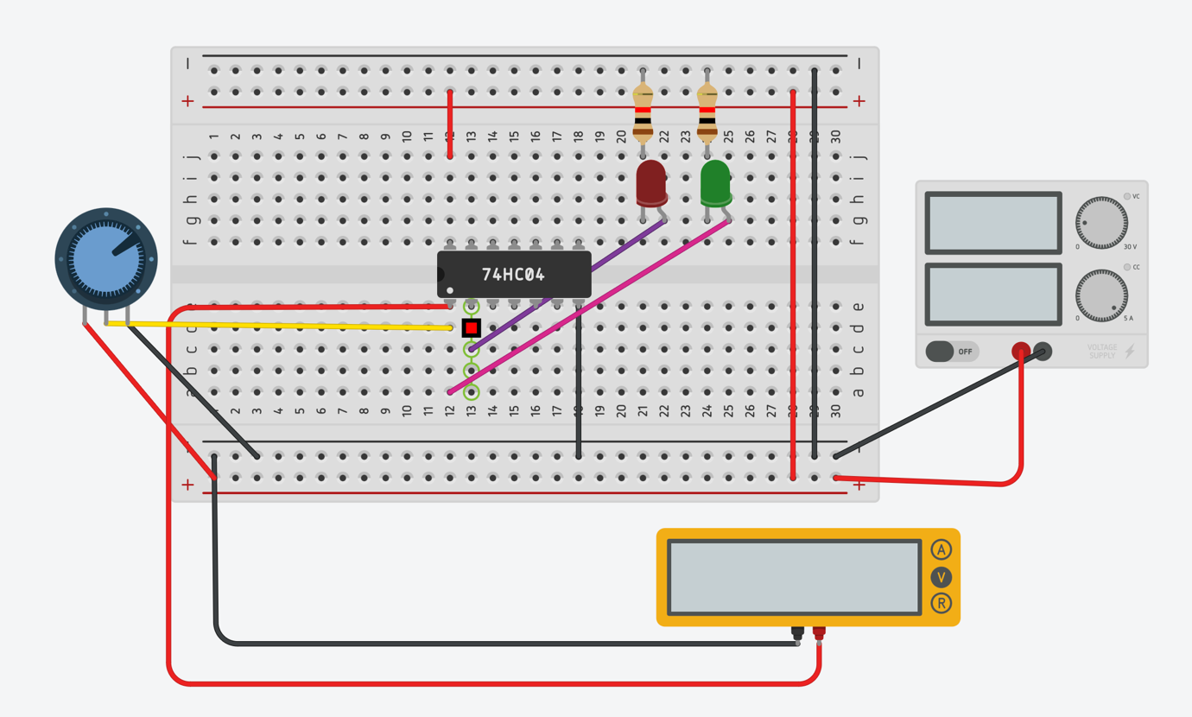

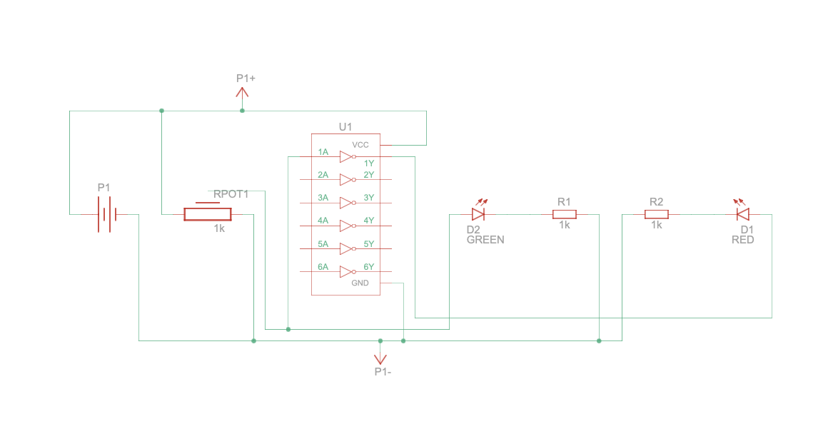

Procedure-

1. Connect the VCC and GND pins of the IC to the VCC and GND of the digital test kit.
2. Connect the extreme ends of the potentiometer to the vcc and gnd
3. Give input to the not gate from middle pin of the potentiometer
4. Give the output from the not gate to the led

Observation-

1. When the potentiometer is in minimal resistance condition, the led with directly connection to the input glows.
2. When potentiometer is shifted to the side with more resistance the previous glow led dims and the one connected through not gate starts to glow
3. When the potentiometer is at maximum resistance, the led with direct input shuts off and the other one glows up.
4. Threshold voltage is 2.44 V i.e. color of the LED changes from green to red at this voltage.

Conclusion-

1. When the potentiometer dial is rotated, the resistance changes between the circuit causing the current values to change to an extent at which not value changes its input to 0 from 1 while increasing the resistance.
2. The resistance when lower, the led with direct input glows and the one with not gate glows when the resistance is at max value as the not gate takes input as 0.

Simulation link:-

https://www.tinkercad.com/things/5APmM6oHSSW?sharecode=usDcTOPgXVKQv_FCSKVtIdhq219sXZDrHhfRW7lD0rs

Part B:- Gate identification

Objective :- To identify various gates

Electronic components required:-

1 Breadboard

2 Connecting wires

3 Led

4 Wires

5 Power supply

Reference circuit of TinkerCAD:-

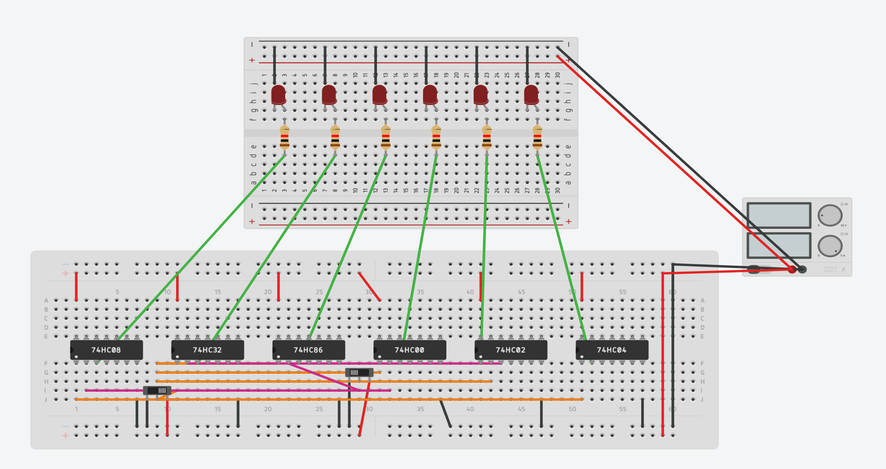

Left side of switch signifies LOW and right side HIGH

Red LED blinking means

output is HIGH and no

blinking means LOW.......

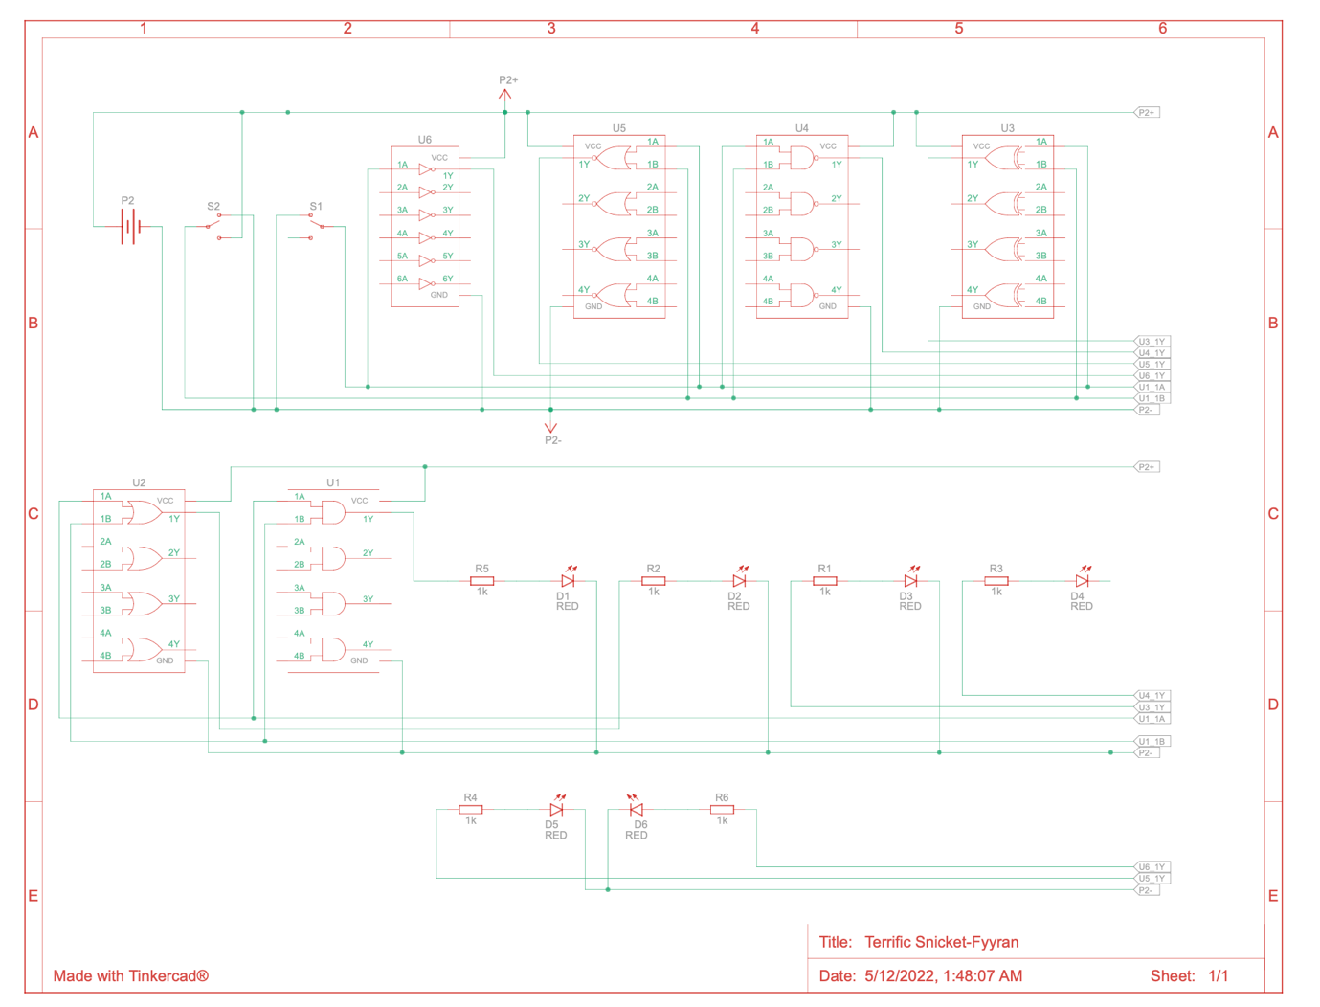

Photo of gate performed in LAB

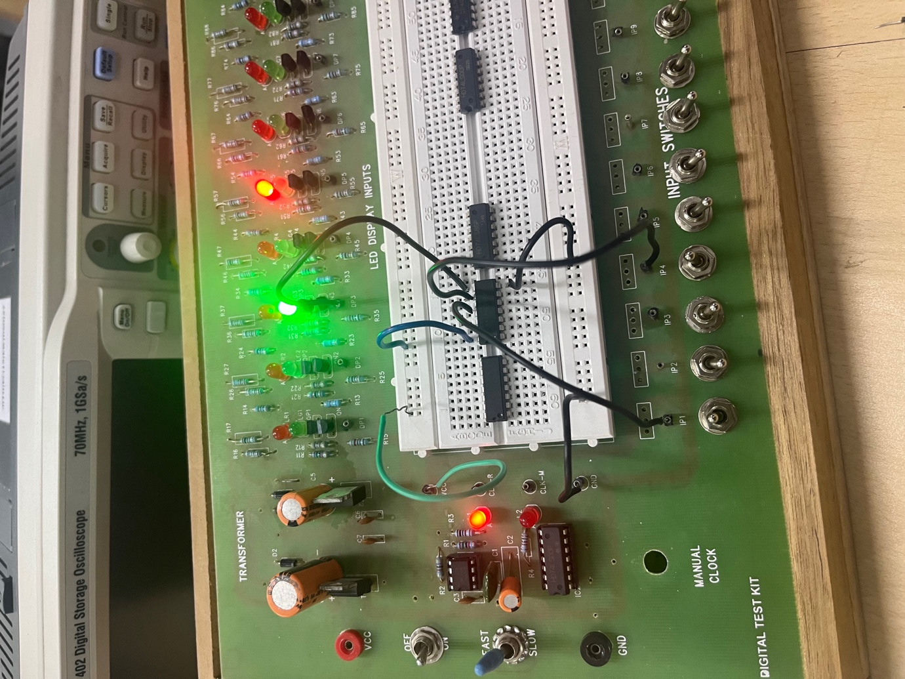

Input using IP1 and 4.

This photo signifies input LOW on both inputs and LOW output…

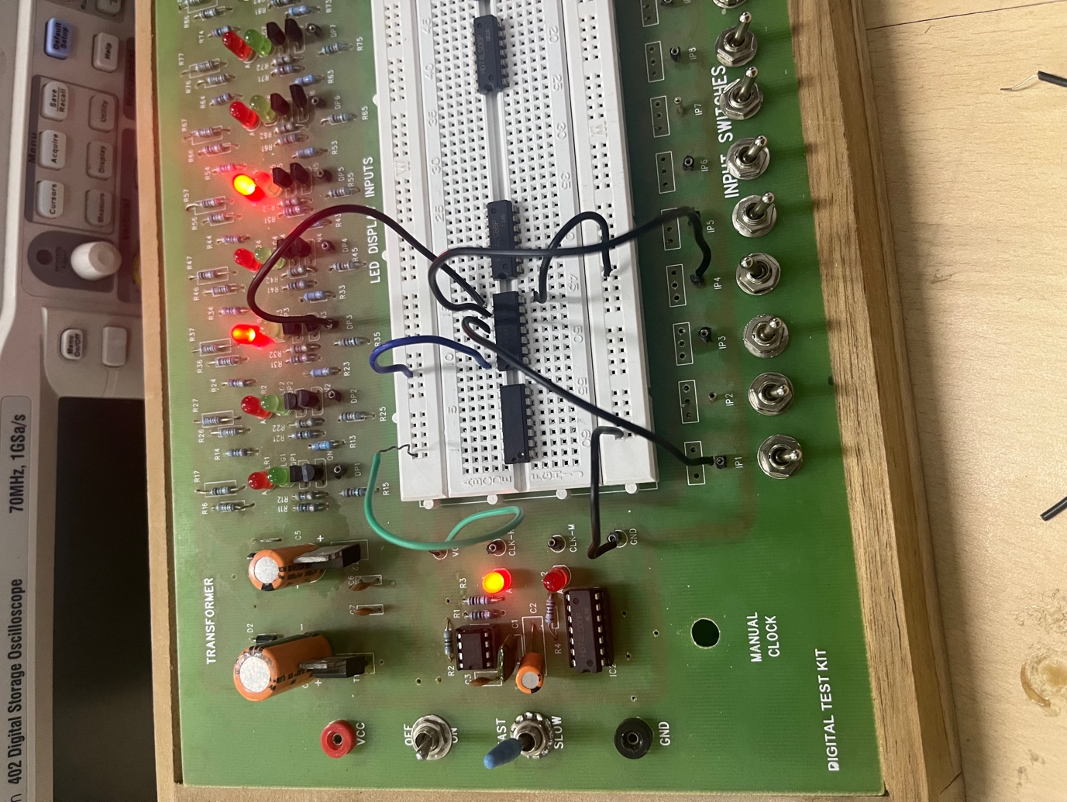

This photo has one input LOW and one input HIGH and output is also HIGH

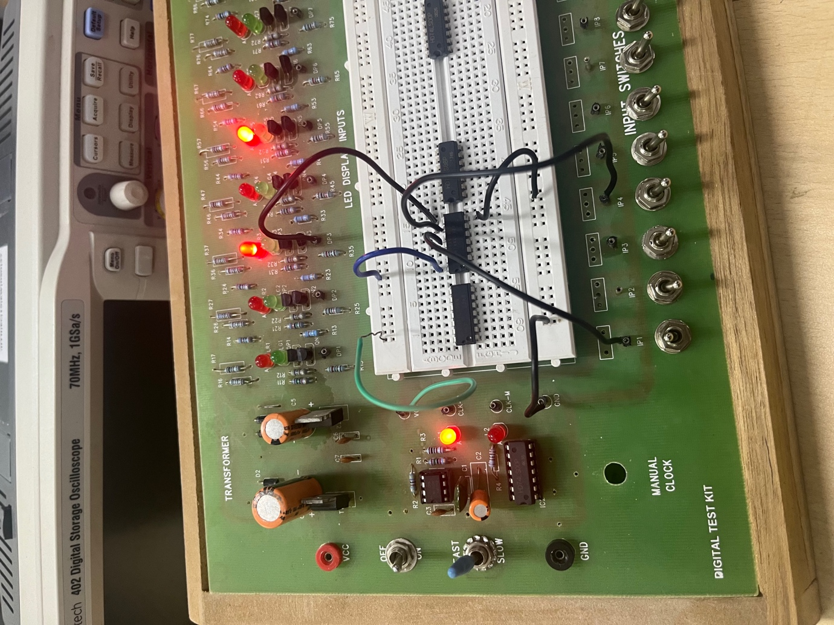

This photo has one input LOW and input HIGH and output is also HIGH.

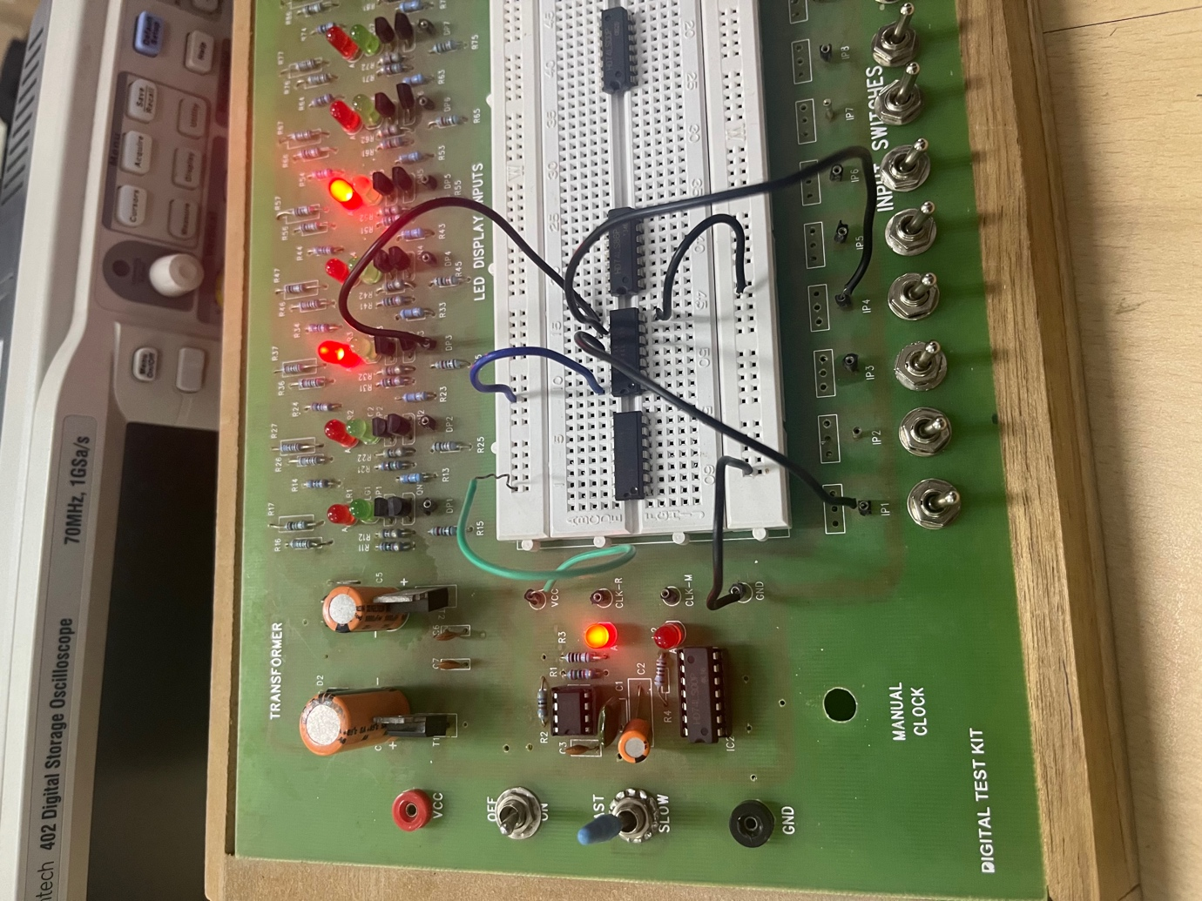

This photo has Both inputs high and output is also HIGH..

Procedure:-

1 Connect all the ICs to ground and power supply on breadboard

2 Make all the suitable connections to all the ICs and note the outputs of all combinations of inputs….

Table of various ICs and inputs(Observation):-

|  |  |  |  |  |  |  |  |
| --- | --- | --- | --- | --- | --- | --- | --- |
| INPUT1 | INPUT2 | 7408 | 7432 | 7486 | 7400 | 4001 | 4011 |
| 0 | 0 | 0 | 0 | 0 | 1 | 1 | 1 |
| 0 | 1 | 0 | 1 | 1 | 1 | 0 | 1 |
| 1 | 0 | 0 | 1 | 1 | 1 | 0 | 1 |
| 1 | 1 | 1 | 1 | 0 | 0 | 0 | 0 |

From our prior knowledge of truth table we can conclude that :-

IC 7408- AND gate

IC 7432- OR gate

IC 7486- XOR gate

IC 7400- NAND gate

IC 4001- NOR gate

IC 4011- NAND gate

Simulation link:-

https://www.tinkercad.com/things/kU5tZ2ek2TI?sharecode=5iXDoJL8VEK_l_asEKu5ILk8wRE26rUKmA_0tG2hZ8I

Part C:- DeMorgan’s Law

Objective:- To verify DeMorgan’s law.

Electronic components required:-

1. And gate
2. Or gate
3. Nand gate
4. Wires
5. Digital Test Kit

Reference circuit of TinkerCAD:-

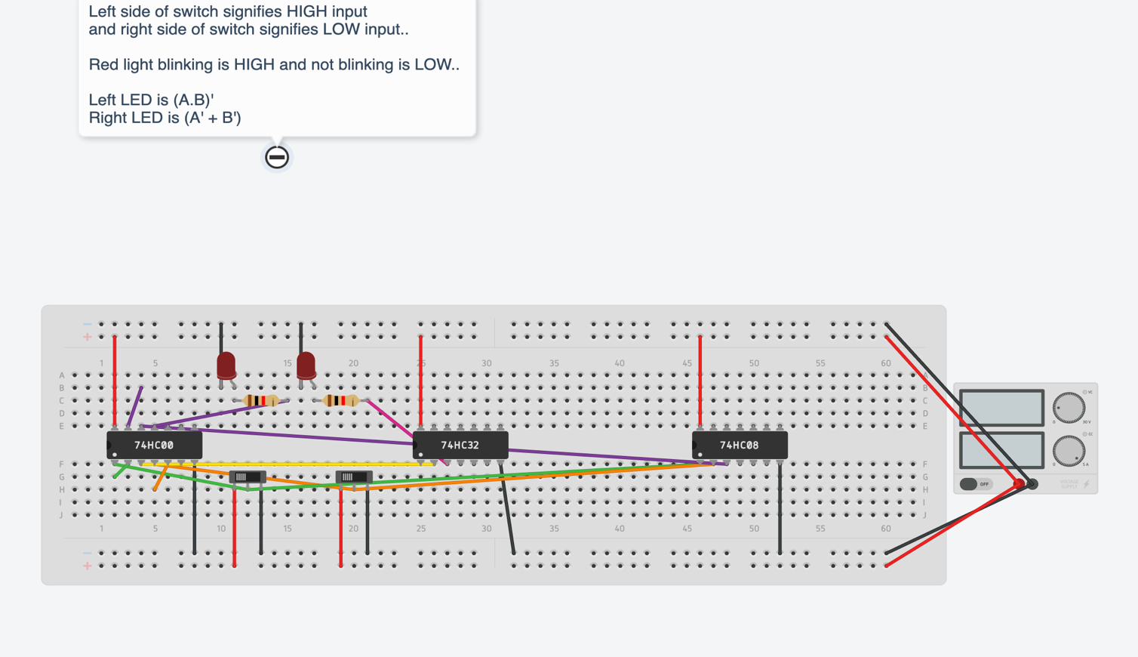

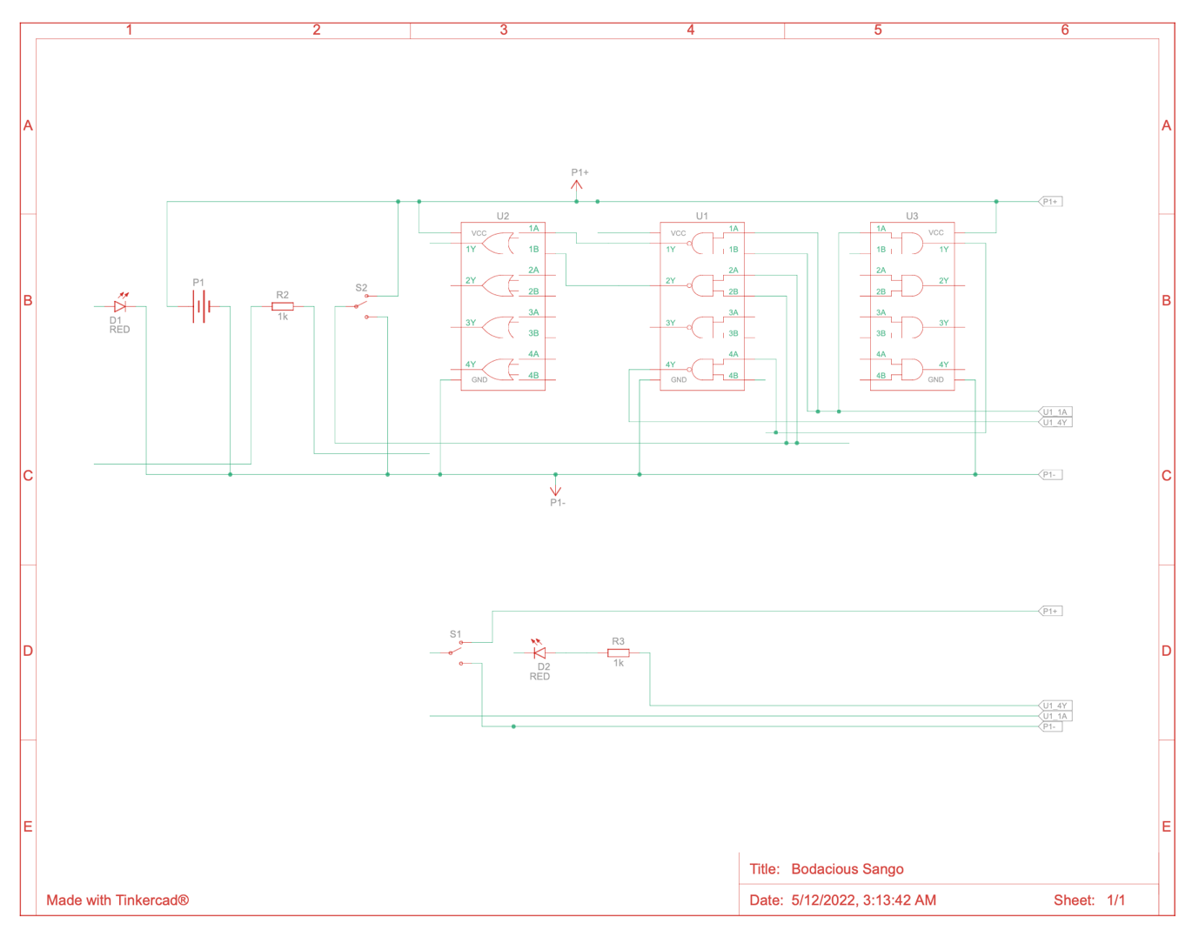

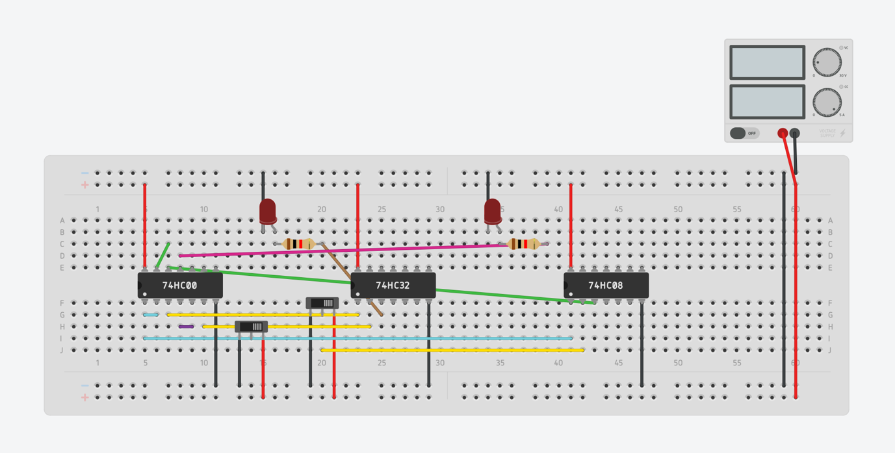

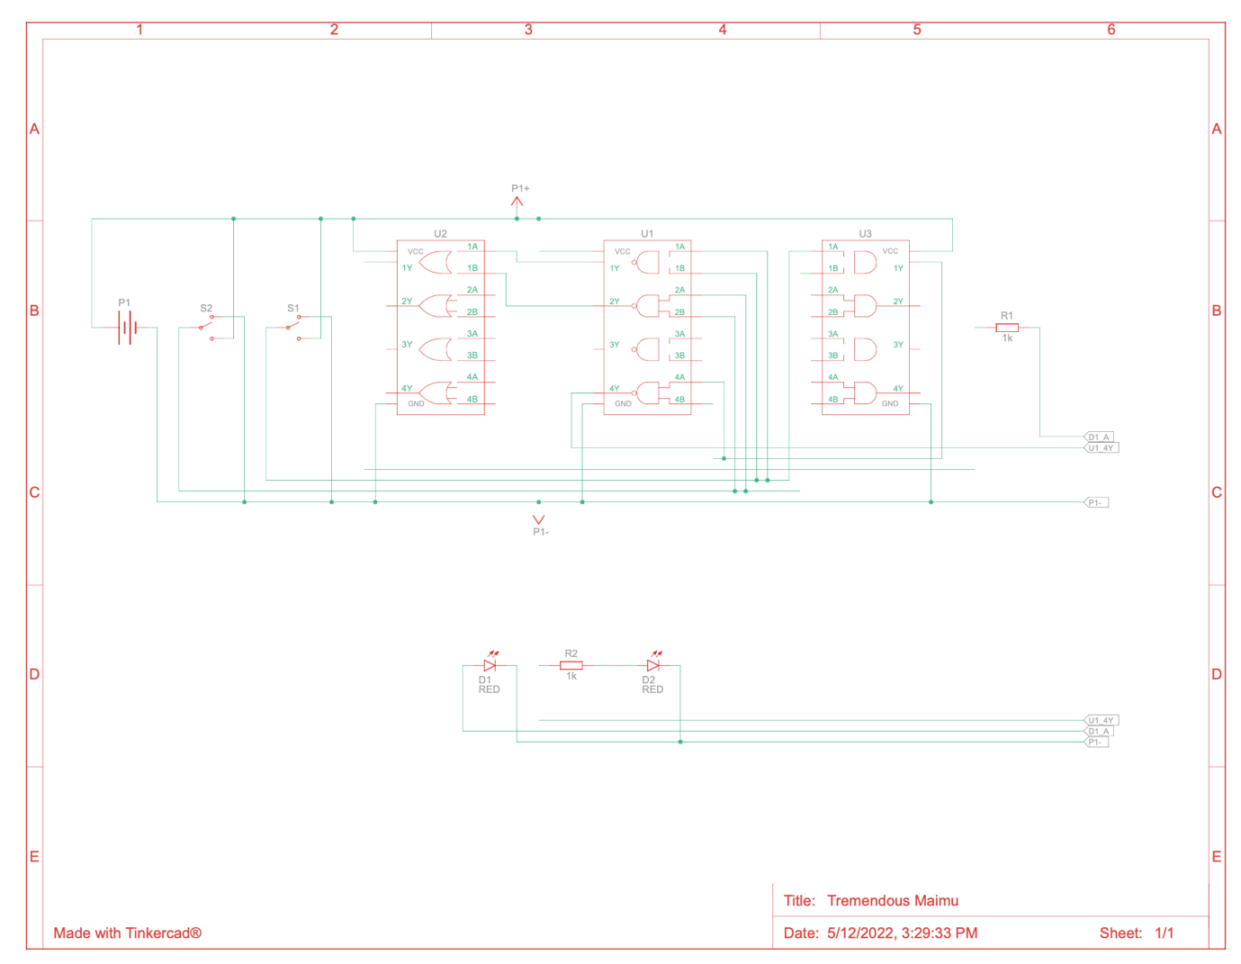

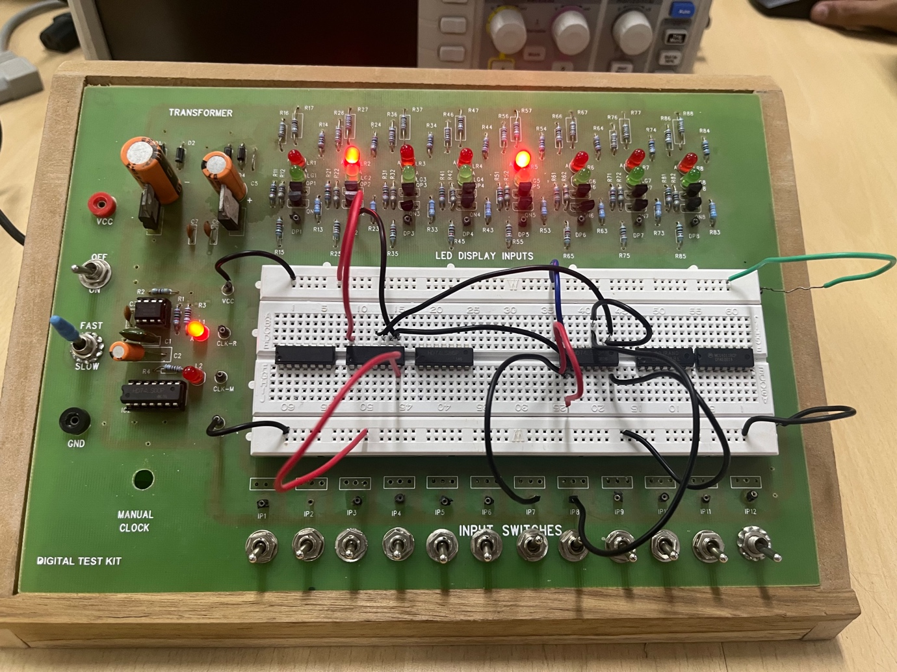

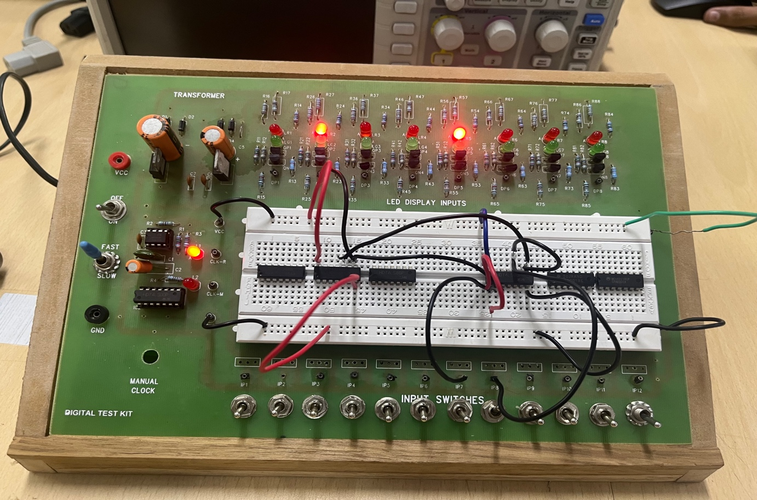

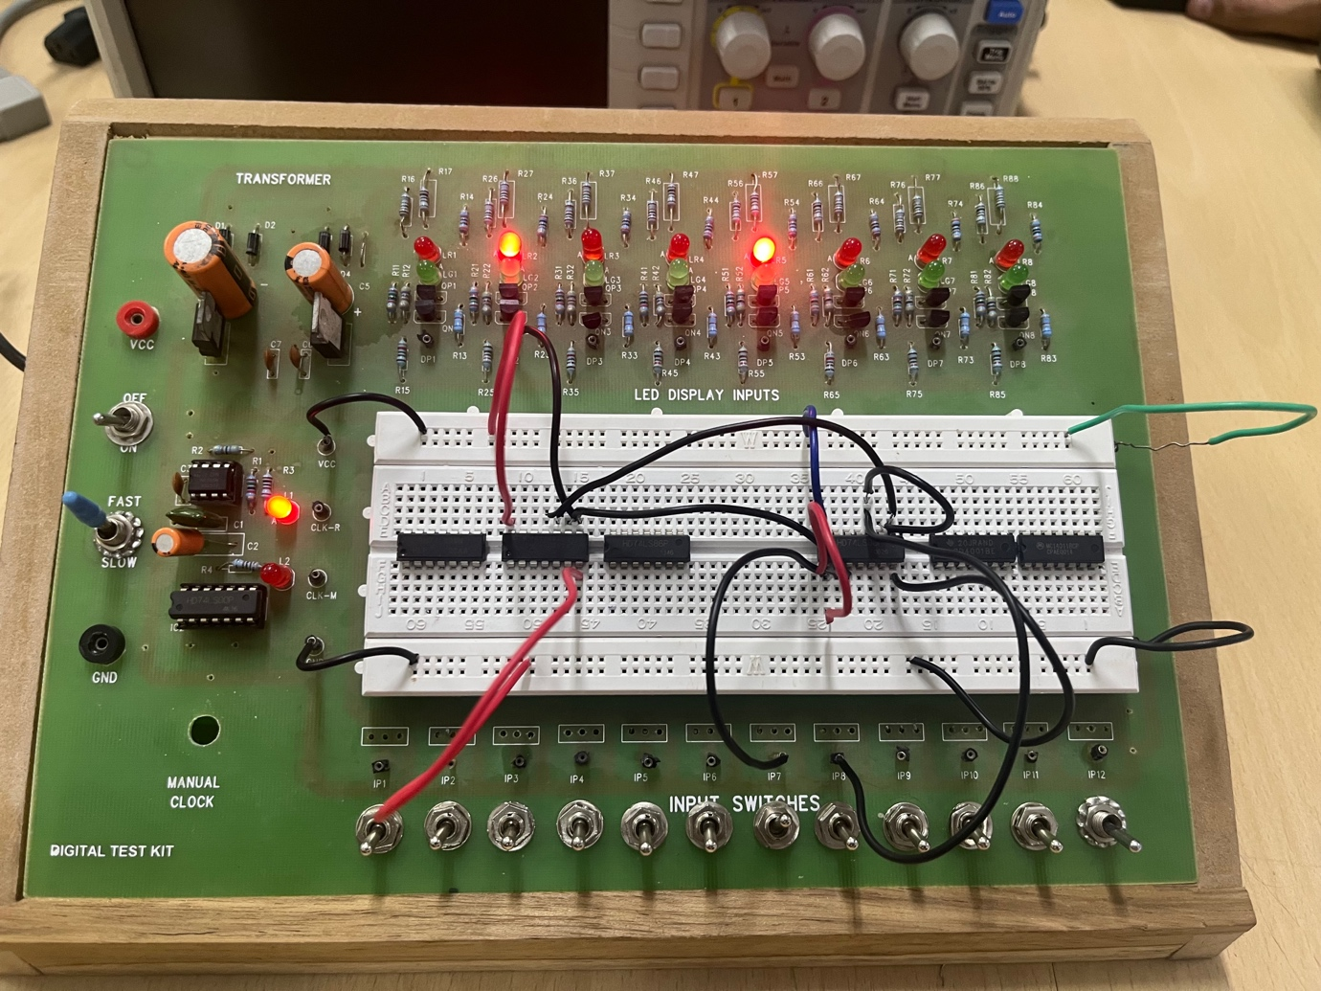

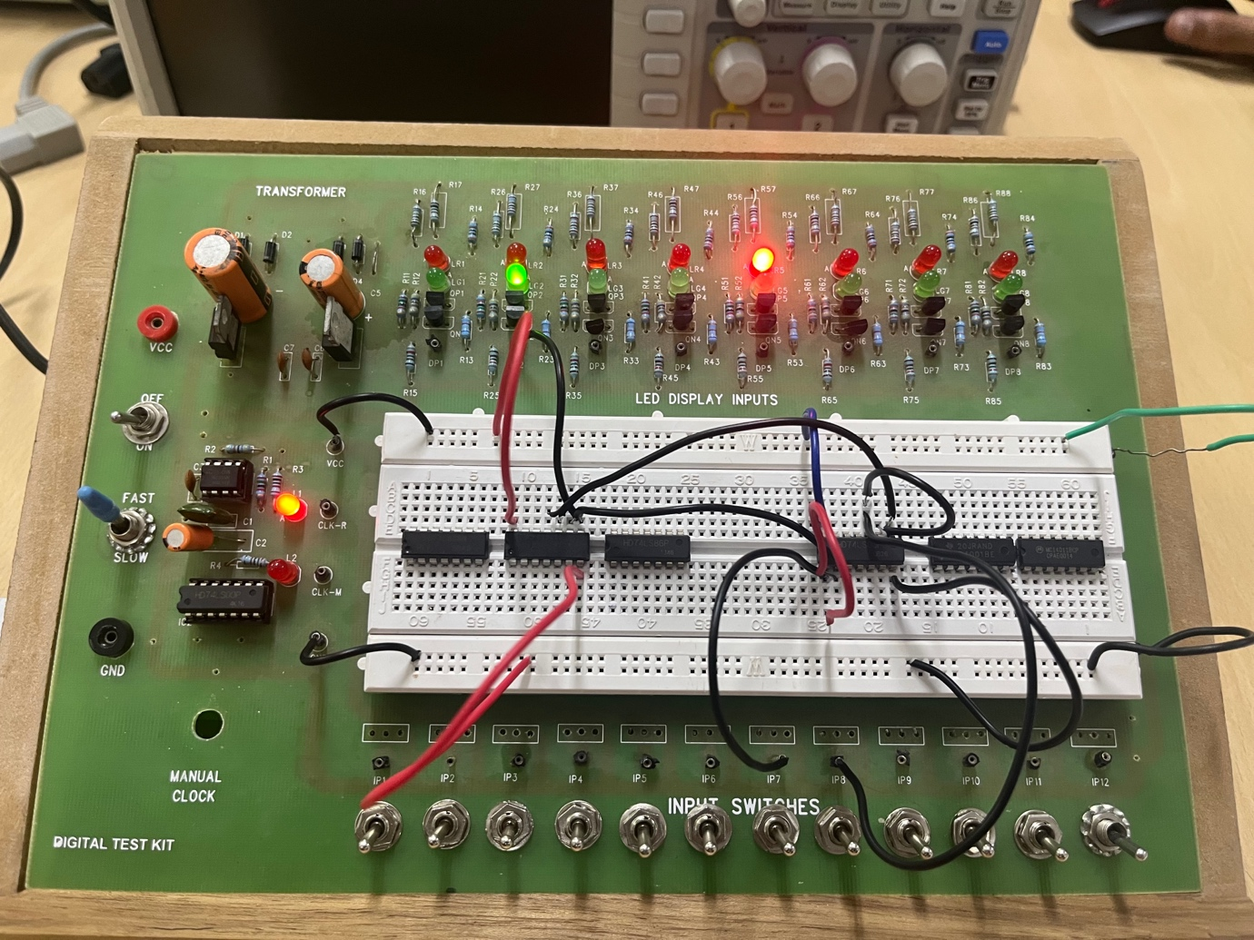

Procedure:-

1. Connect the VCC and GND of IC to VCC and GND of the digital test kit.
2. For the first law (A+B)’=A’B’, first connect any two input switches from IP-1 to IP-12 to an OR gate then connect the output to a Not gate and connect the output to any one of the display pins DP1-DP8 and then take the same input, connect it to a not gate then connect it to an and gate and then connect the output to and check if it shows the same output for different binary values of the input.
3. For the second law (A.B)’=A’+B’, first connect the input from any two input switches from IP1- IP12 and connect the output to the not gate and connect the output of that gate to any one of the display pins DP1-DP8. Then use the same input and connect it to the not gate and then use both the outputs and connect it to an or gate and check if it shows the same output for different binary values of the input.

Observation:-

First DeMorgan’s LAW:

|  |  |  |  |  |  |  |
| --- | --- | --- | --- | --- | --- | --- |
| A | B | A’ | B’ | A’+B’ | A.B | (A.B)’ |
| 0 | 0 | 1 | 1 | 1 | 0 | 1 |
| 0 | 1 | 1 | 0 | 1 | 0 | 1 |
| 1 | 0 | 0 | 1 | 1 | 0 | 1 |
| 1 | 1 | 0 | 0 | 0 | 1 | 0 |

Second DeMorgan’s LAW:

|  |  |  |  |  |  |  |
| --- | --- | --- | --- | --- | --- | --- |
| A | B | (A+B) | (A+B)’ | A’ | B’ | A’.B’ |
| 0 | 0 | 0 | 1 | 1 | 1 | 1 |
| 0 | 1 | 1 | 0 | 1 | 0 | 0 |
| 1 | 0 | 1 | 0 | 0 | 1 | 0 |
| 1 | 1 | 1 | 0 | 0 | 0 | 0 |

Conclusion:-

We can conclude both the DeMorgans LAW from above …

Simulation link:-

First DeMorgan’s LAW:-

https://www.tinkercad.com/things/5BrgEwFNzef?sharecode=heIlW66gMEaxlQRC9iC8icQk0ApEA0M954J4ye_5BQ8

Second DeMorgan’s LAW:-

https://www.tinkercad.com/things/inLN9NYuqjk?sharecode=OSHnecX-SgWRdpqiT8O7iVLLGj7j20gIwIg8yEPb7Jg

Part D:- Binary Full Adder

Objective:- To Create Binary Full Bit Adder using Digital Test Kit

Electric components Required:-

1. AND gate
2. XOR gate
3. Wires
4. Digital Test kit

Reference circuit of tinkerCad:-

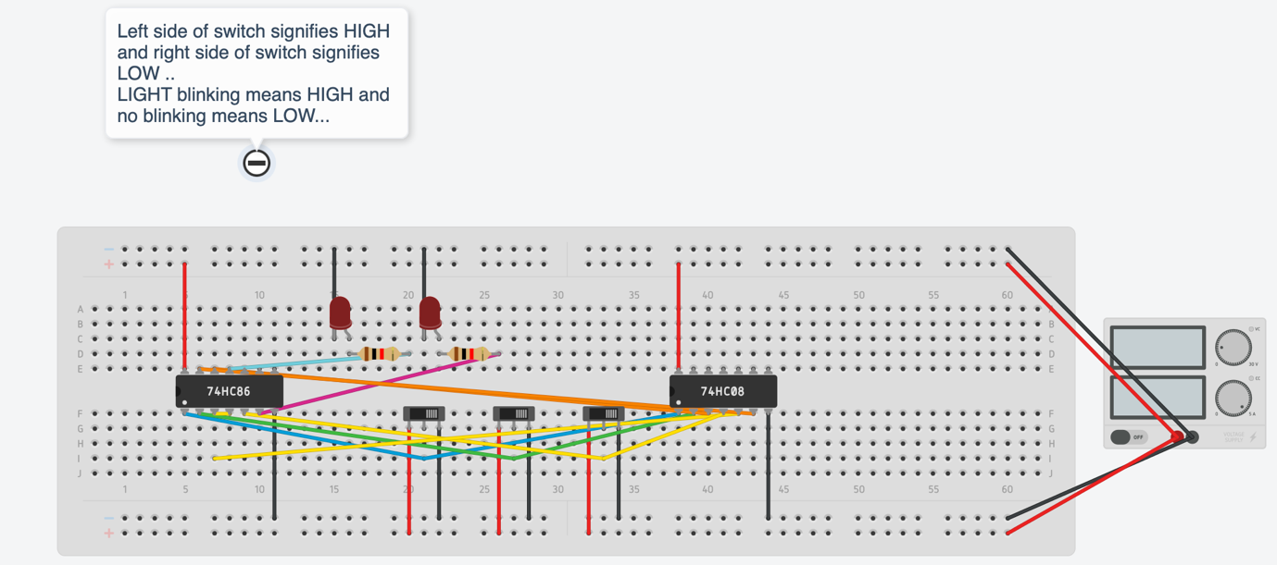

LEFT is CARRY

RIGHT is SUM

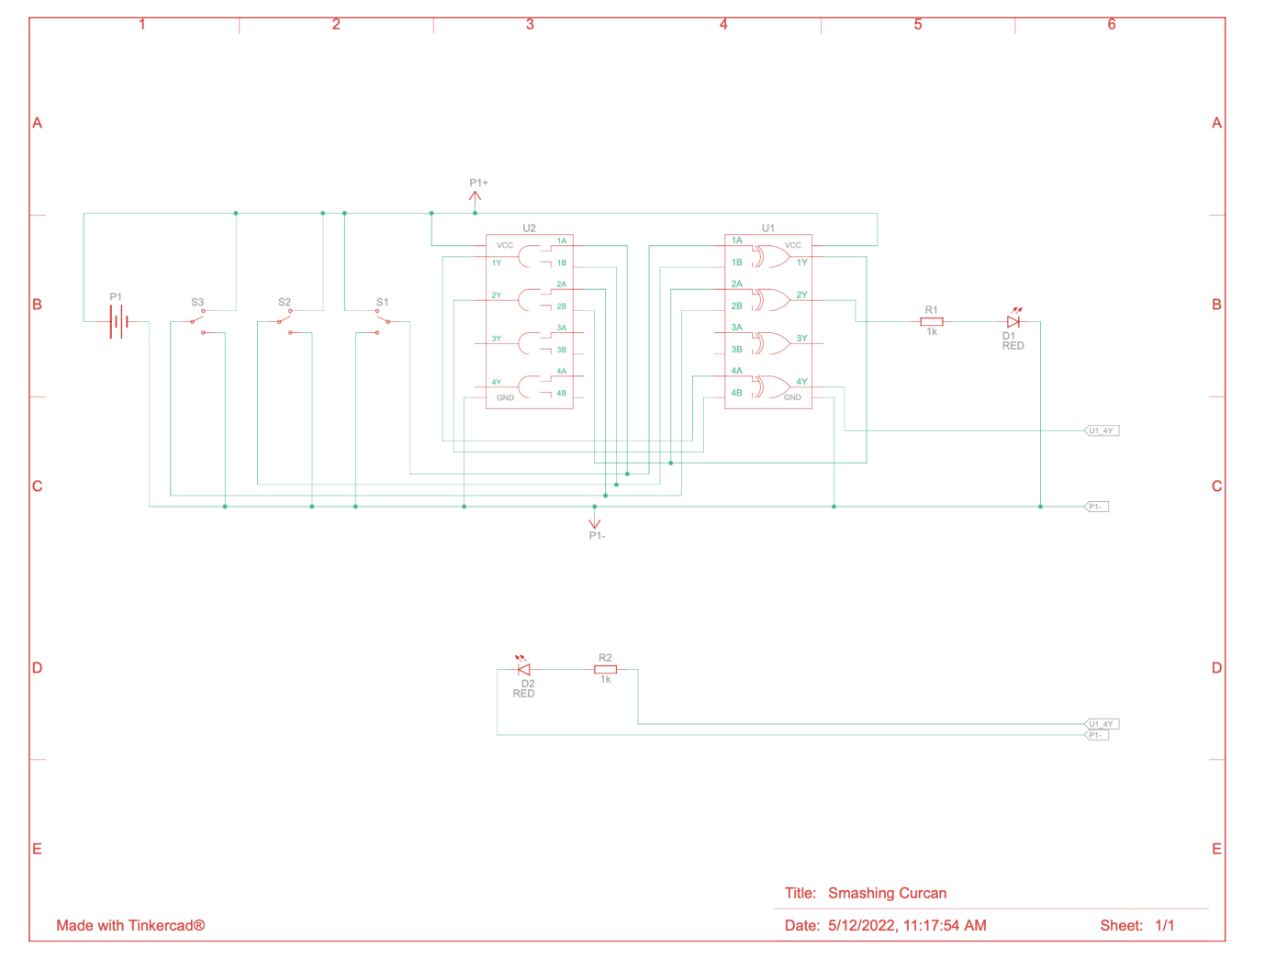

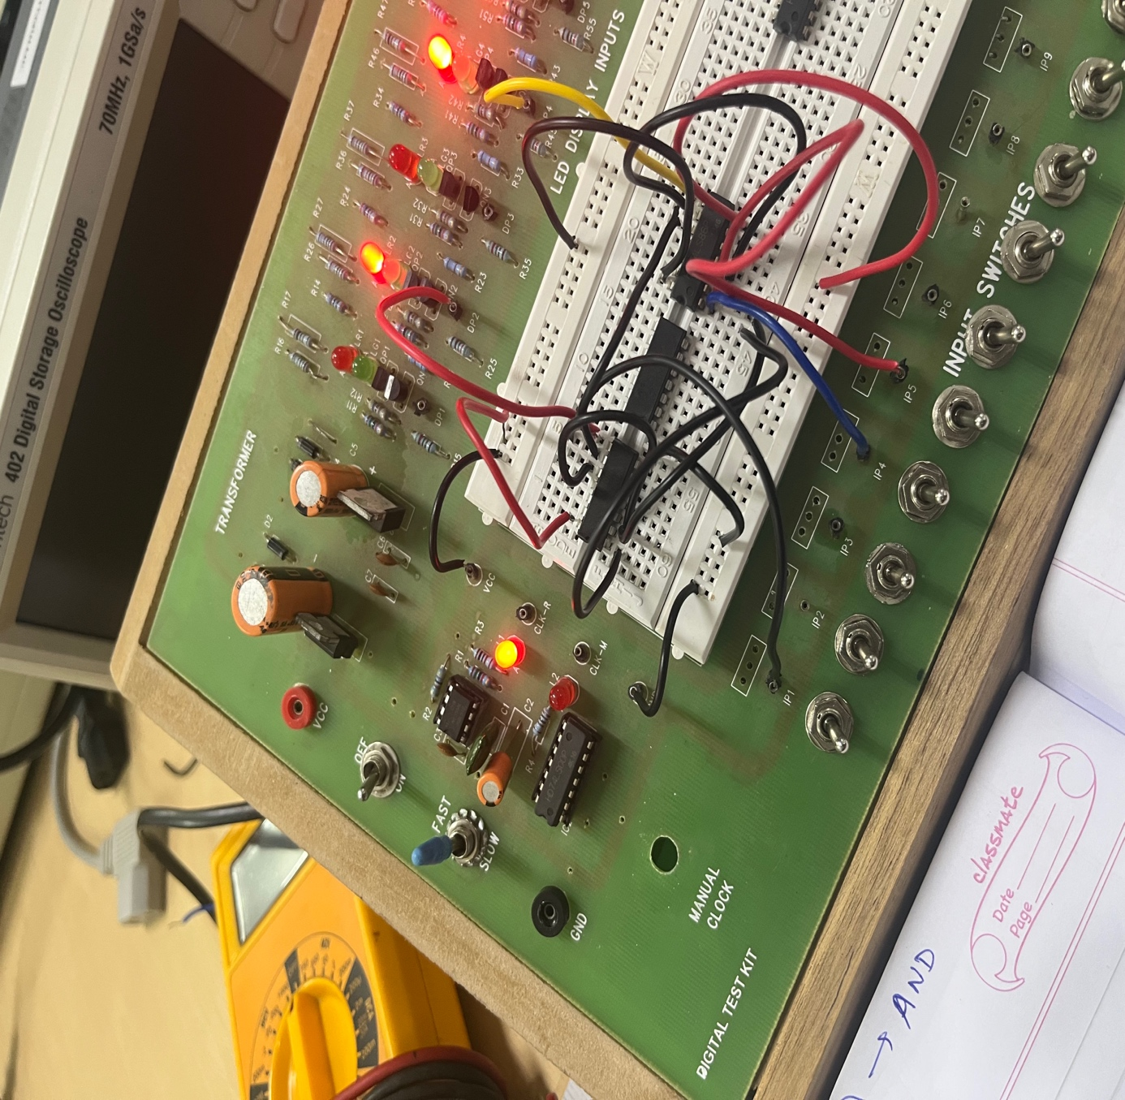

Procedure:-

1. Connect the VCC and GND of IC to VCC and GND of the digital test kit.
2. Connect any two the input switches from IP-1 to IP-12 to the input pins of the Xor gate and connect the output of the Xor gate to the input switch of XOR gate and connect a third input switch to the input pin of the XOR gate and connect the output of the Xor to any one display switch from DP-1 to DP-8. This will represent sum bit.
3. Connect the same first two inputs to the input pins of and gate and connect the output with input of XOR and connect the third input switch to the XOR gate and take XOR of it with Xor of the first and second input switch and connect the output of it to Xor gate with one input as and of first two input switches then connect the output pin to any one display switch DP1-DP8. This will represent the carry bit.

S1=A⊕B

C1=A.B

Output C1 and S1 are binary half adder

Binary full adder is obtained using 2 half adders.

SUM=S1⊕C

C2=S1.C

CARRY=C1⊕C2

Observation:-

|  |  |  |  |  |  |  |  |
| --- | --- | --- | --- | --- | --- | --- | --- |
| A | B | C | S1 | C1 | SUM | C2 | CARRY |
| 0 | 0 | 0 | 0 | 0 | 0 | 0 | 0 |
| 0 | 0 | 1 | 0 | 0 | 1 | 0 | 0 |
| 0 | 1 | 0 | 1 | 0 | 1 | 0 | 0 |
| 0 | 1 | 1 | 1 | 0 | 0 | 1 | 1 |
| 1 | 0 | 0 | 1 | 0 | 1 | 0 | 0 |
| 1 | 0 | 1 | 1 | 0 | 0 | 1 | 1 |
| 1 | 1 | 0 | 0 | 1 | 0 | 0 | 1 |
| 1 | 1 | 1 | 0 | 1 | 1 | 0 | 1 |

Conclusion:-

Binary full adder is made using 2 half adders.

Simulation link:-

<https://www.tinkercad.com/things/jsrdChEmkQ0?sharecode=KPfcBOc1tED3iAiikM98KdqsYv3vFiX7duOdfA61y0o>

4